Project Title

Library Management System

Guided By:

Trainer Name:- Anuj Kumar

Created By:-
Student Name | AFid
Atal Kumar Pandey | AF04991842
Devendra Gupta | AF04991767
Piyush Kumar | AF04991733

Batch Code : ANP-D2405

Course Code : ITPR

- Introduction
A Library Management System is a software application designed to automate and simplify the processes involved in managing a library. Traditional library operations—such as book issuing, returning, cataloging, user registration, and maintaining records—are usually time-consuming and prone to human error. This system provides a digital platform that ensures accuracy, efficiency, and easy access to library information.The proposed LMS will support both students/members and library staff, enabling smooth book circulation, inventory management, and report generation.

- Objectives
- The main objectives of the Library Management System are:
- To automate manual library operations.
- To maintain digital records of books, members, and transactions.
- To provide quick and efficient book search functionality.
- To reduce paperwork and minimize human errors.
- To track issued/returned books and calculate fines automatically.
- To generate useful reports for administration.

Project Category
Application Development using Java & MySQL

Problem in Existing System
- Paper forms are difficult to manage
- Records cannot be searched quickly
- High chances of human errors
- Document verification is slow
- Fees tracking becomes confusing
- No proper backup of student data
- Difficult to maintain long-term records

Proposed System
The proposed LMS will:
- Digitize book and member records
- Provide a user-friendly interface
- Offer real-time status of book availability
- Automate issuing and returning transactions
- Automatically calculate fines
- Generate daily, weekly, and monthly reports
This system will enhance efficiency, accuracy, and accessibility.

Modules Description
1. Admin Module
This module is the core control panel of the Library Management System. It allows the administrator to manage all master-level data and oversee daily operations.
• Manage Books, Categories, Authors
- The admin can add new books into the system with details such as title, author, category, ISBN, edition, and publication year.
- Books can be updated, deleted, or marked as unavailable.
- Admin can create and maintain different book categories (e.g., Science, Literature, Commerce).
- Authors’ information can be added and updated to classify books effectively.
• Manage Members
- Admin can register new members/students and maintain their profiles.
- The module handles membership activation, renewal, or blocking in case of misuse.
- Admin can view a member’s issue history, fines, and book requests.
• View Reports
- Admin can generate various system reports such as book stock status, most issued books, pending returns, fines collected, etc.
- These reports help in decision-making and monitoring daily library operations.

2. User / Member Module
This module is designed for library users or students, enabling them to interact with the system independently.
• Search Books
- Members can search for books by title, author, category, or ISBN.
- The system shows availability status (Available/Issued/Reserved).
- Users can view detailed book information.
• View Issued Books
- Members can view all books currently issued to them with due dates.
- This helps users avoid late returns and fines.
• Request for Book Issue / Renewal
- Users can request a book issue if it is available.
- If the book is nearing the due date, users can submit a renewal request.
- The admin/librarian approves or rejects these requests based on rules and availability.

3. Transaction Module
This is the functional module where all book-related transactions are recorded and maintained.
• Issue, Return, Renew Books
- Librarian issues books to members after checking availability and membership validity.
- When the book is returned, the module updates the database and marks the book as available again.
- Renewal transactions extend the due date if allowed.
• Fine Calculation
- Automatically calculates overdue fines based on the number of delayed days.
- Updates the user’s account showing pending fines.
- The librarian can collect the fine and update the record.

4. Report Module
This module provides analytical and operational reports for both admin and management.
• Book Inventory Reports
- Displays total books, available books, issued books, and damaged/lost books.
- Helps the library understand stock levels and plan purchases.
• User Activity Reports
- Shows user activities such as books searched, books requested, books issued, renewal history, and fines paid.
- Useful for tracking user engagement and identifying heavy users.
• Transaction History
- Maintains a complete record of all transactions including issue, return, etc.
- renew, fines, and reservations.
- Helps in audits, verification, and future reference.

Database Design (6 Tables)

Table 1: admission:
Field Name | Data Type | Description
student_id (PK) | INT | Unique student ID
name | VARCHAR(100) | Student’s full name
father_name | VARCHAR(100) | Father's name
dob | DATE | Date of Birth
gender | VARCHAR(10) | Male/Female/Other
course_id (FK) | INT | Linked to course table
mobile | VARCHAR(15) | Contact number

Table 2: course:
Field Name | Data Type | Description
course_id (PK) | INT | Unique course ID
course_name | VARCHAR(100) | Name of the course
duration | VARCHAR(50) | Duration (e.g., "6 months", "1 year")
fees | DECIMAL(10,2) | Total course fee

Table 3: qualification:

Table 4: fees:
Field Name | Data Type | Description
fee_id (PK) | INT | Unique fee record
student_id (FK) | INT | Linked to student
total_fees | DECIMAL(10,2) | Total payable
paid | DECIMAL(10,2) | Amount paid
balance | DECIMAL(10,2) | Remaining amount

Table 5: address:
Field Name | Data Type | Description
address_id (PK) | INT | Unique record
student_id (FK) | INT | Linked to student
house_no | VARCHAR(50) | House/Flat number
street | VARCHAR(100) | Street name
city | VARCHAR(50) | City
state | VARCHAR(50) | State
pincode | VARCHAR(10) | Postal code

Table 6: documents:
Field Name | Data Type | Description
doc_id (PK) | INT | Unique document record
student_id (FK) | INT | Linked to student
aadhar_no | VARCHAR(20) | Aadhar number
tenth_marksheet | VARCHAR(255) | File path / scan stored
twelfth_marksheet | VARCHAR(255) | File path / scan stored
photo | VARCHAR(255) | Student photo

ER Diagram Overview | Description
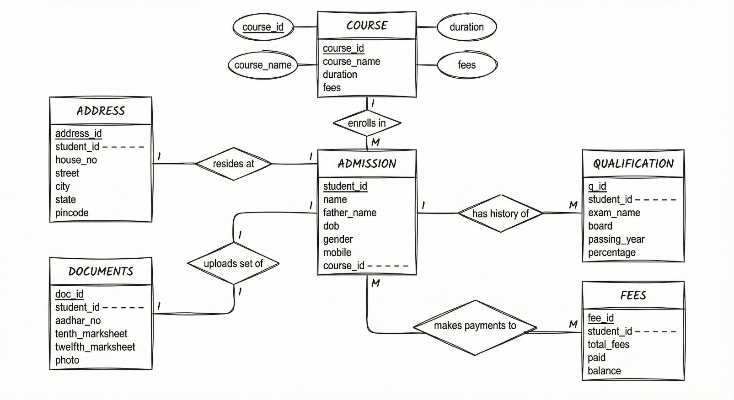

Data Flow Diagram (DFD)

DFD Level 0:

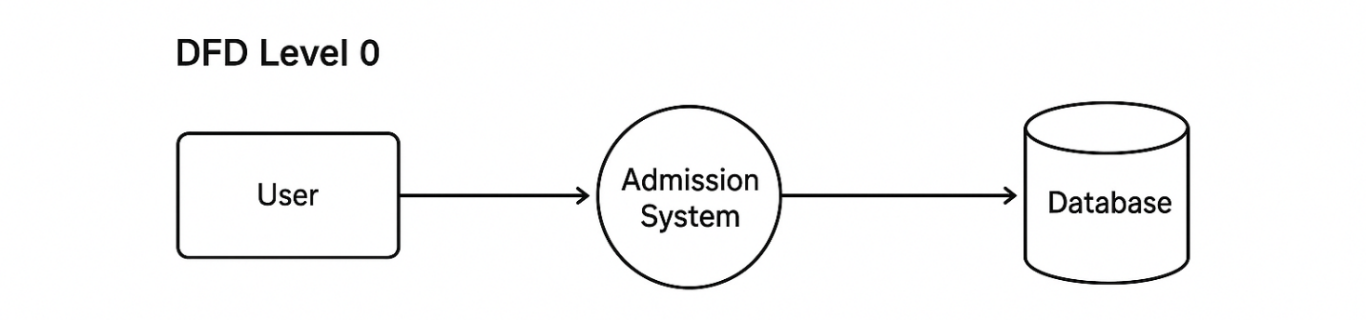

DFD Level 1:

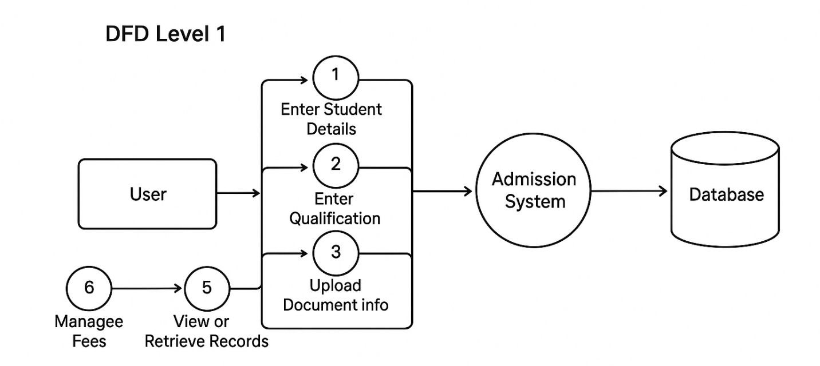

Platform Used

Hardware Requirements
- Intel processor
- 4 GB RAM
- 200 MB free disk space

Software Requirements
- Windows 10/11
- Java JDK (17 or above)
- Eclipse IDE
- MySQL Server & MySQL Workbench
- JDBC Connector JAR
Future Scope
- Add graphical user interface (GUI)
- Online admission portal
- Admin login and authentication
- Automatic report generation (PDF/Excel)
- Multi-course enrollment
- Biometric or digital document verification

